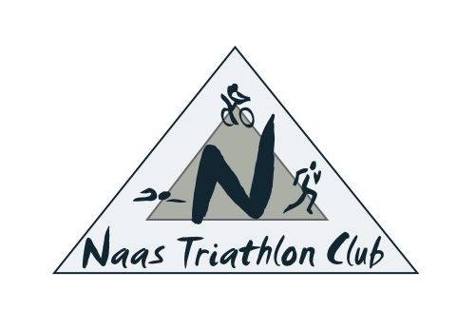
Naas Triathlon Club – Coach Roles and responsibilities
Conduct
At all times club coaches should be advocates for the highest levels of:
- Respect for Triathletes and Others.
- Integrity in Relationships.
- Personal Standards.
- Professional Responsibilities and Competency.
- Fair Play.
- Clean Sport (Anti-Doping)
General
• All Coaches are to work under the guidance and organisation of the Naas Triathlon Club training officer
• All Coaches must hold adequate qualifications and experience to coach in their discipline
• All Coaches must hold necessary Safeguarding qualifications (if working with Minors and/or Vulnerable Adults)
• All Coaches must be trained in first aid
• Take full responsibility for any coaching session where they are the nominated Lead Coach
• Prepare sessions in advance, with a session plan (where applicable) for support coaches/assistants
• Monitor safety at all times during a session in accordance with Triathlon Ireland rules and regulations
• Ensure the safety of Minors and Vulnerable Adults in accordance with Triathlon Ireland rules and regulations
• Be aware of and compliant with Naas Triathlon Club Risk Assessments and Emergency Action Plans (EAPs) for all sessions
• Carry out dynamic risk assessments at venues as required Ensure any training venue or area used is left as it was found and check the area before departure.
• Report any damages/issues with the venue to the venue manager, where applicable
• Manage any incidents during and after any session, including supporting the completion of relevant documentation
• Liaise with the Naas Triathlon Club training officer regarding sessions and areas for improvement
Swim Coach
• Determine ability and skill level before setting up training programs
• Develop and implement training programs that focus on improving technique, stroke placement, speed, and style
• Analyse strokes, techniques, and monitor progress. Teach new swimming styles or strokes
• Teach and perfect swimming skills
• Educate swimmers on water safety and best practice
• Use a range of activities to improve water confidence
• Ensure the pool or training area is clean, well-maintained, and free of hazards
Run turbo sessions
• Teach about bike and turbo set up and maintenance, including bike safety
• Develop and implement training programs that focus on improving technique, speed and power
• Teach and perfect bike skills
• Educate cyclists on road safety and best practice
• Use a range of activities to improve cycling confidence
Run Coach
• Determine ability and skill level before setting up training programs
• Conduct running sessions
• Develop and implement training programs that focus on improving technique, speed and power
• Educate runners on road safety and best practice
• Use a range of activities to improve run confidence

