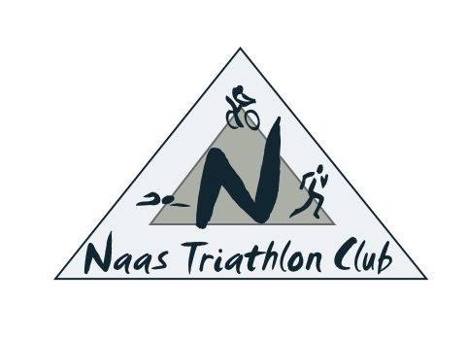
Naas Triathlon Club – Code of Conduct for Volunteers

Safeguarding steps: Volunteers who will be helping with juniors or vulnerable adults must complete the following steps:
1. Garda Vetting or Access NI check.
2. Attend a 3 hour Safeguard 1 course (Child protection in sport basic awareness course).
3. Sign and agree to abide by the TI code of conduct (Form 8 or Form 10), providing references if they are new to the club (Form 8). This form is returned to the TI office where reference checks are carried out.
The code of conduct provides the foundation for expected and required behaviour of volunteers/coaches/leaders. It asks a series of declarative questions and asks that the applicant agree to abide by the TI code of conduct or be subject to disciplinary proceedings. By signing this the applicant also agrees to a potential review of their role in the future.
• Those volunteering in a club setting who have not undergone safeguarding procedures cannot begin their role until their vetting is returned and they have received an email from the National Children’s Officer. This email states whether their vetting has been successful.
• Those helping as a once off at an event who have not undergone safeguarding procedures should be supervised by qualified volunteers nominated by the Children’s Officer and should be given roles with minimal interaction with the competing junior athletes.
• All volunteers should be advised of their specific role and what is expected of them as well as their rights as a volunteer as per the Volunteer Code of Conduct (below).
• Volunteers should feel comfortable to come forward if they are unhappy about anything regarding safety or safeguarding and feel supported by the club Children’s Officer.
• Volunteers should be informed of how and who to report to either in a club or event setting.
• The club Children’s officer should keep a database of volunteers in the club recording the date of their last vetting with TI, the date they attended the Safeguard 1 course and the date they signed the code of conduct for the year. Triathlon Ireland Volunteers Code of Conduct. Triathlon Ireland Volunteers Should Triathlon Ireland Volunteers Should Not
