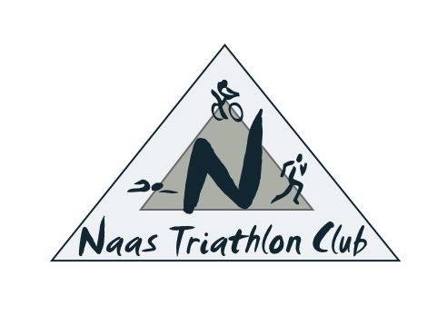

Naas Triathlon Club – Code of Conduct for Coaches and Athletes
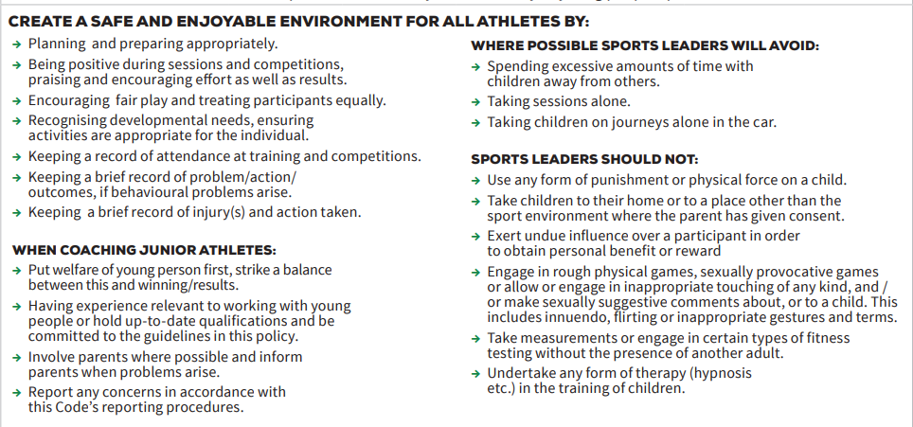
The member/athlete will:
•Accept responsibility for their own behaviour and performance in training and in competition
•Treat others with fairness and respect, showing patience with others and respecting diversity
•Act in a dignified manner and not bring the sport or the club into disrepute
•Avoid swearing and abusive language and irresponsible behaviour including behaviour that is dangerous to yourself or others, acts of violence, bullying, harassment and physical or sexual abuse
•Participate in sessions with enthusiasm and to the best of their abilities
•Inform their coach of any other coaching they are receiving
•Follow the coaches’ instructions, including taking responsibility for reading the briefings and risk assessment for the session
•Turn up in good time for the start of the session with suitable footwear and gear, and with adequate arrangements for post-training re-hydration and nutrition made
•Let the coach know of any factors liable to have an impact on their ability to train or compete or their long-term health (e.g. wellness or health issues, medication, injury, illness, impending or recent competition, work or home pressures)
•Whilst in an athlete role, strictly observe a clear boundary between friendship and intimacy with the coach(es)
•If junior, notify a responsible adult if you have to go somewhere (why, where and when you will return)
•Avoid destructive behaviour and leave athletics venues as you find them
•Challenge anyone whose behaviour falls below these standards and those of Triathlon Ireland Welfare policies
•Report any suspected misconduct by other coaches to the Club’s Welfare Officers in the first instance
•Give feedback to the coach on how the session felt for them and whether there are any consequential problems
•Never place undue pressure on children to perform, participate or compete (if applicable)
•Consistently promote positive aspects of the sport such as fair play and never condone rule violations or the use of prohibited or age-inappropriate substances
•Show appreciation to those throughout the club who help them participate in athletics, including the coaches
•Take personal responsibility for warming up before the session and cooling down including stretching after the session
Violations of the Code of Conduct
Coaches or athletes/members who want to raise possible breaches of the Code of Conduct should in the first instance contact a member of the Committee.
Social Media
All users of club social media groups and email must abide by the Code of Conduct. Any reports of offensive comments will be actioned and individuals may be removed from social media groups and/or their club membership cancelled.

